Perform the indicated operations and write the answer in standard form.

1)

2)

3)

Evaluate for

(Hint: Substitute (1+i) in for x )

4)

5) Solve using the quadratic formula.

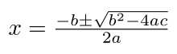

Solutions To Practice Problems

1)

2) 0 + 47i or 47i

3) 0

4)

5) x= 1+i, 1-i